**NAVOne Integration API – Deployment**

Pre-Request

-----------------

1. .Net Core
2. IIS Server
3. SDK Dotnet-core - (https://dotnet.microsoft.com/en-us/download)
4. Windows-hosting-bundle-installer-

(https://dotnet.microsoft.com/en-us/download/dotnet/thank-you/runtime-aspnetcore-6.0.6-windows-hosting-bundle-installer)

This Document describes how to Deploy the Payment API.

Step -1

Download the Payment API deployment files (.zip /. Rar ) from Email or any other resource & put it the location (C:\\Deployment\Payment API\{Current Date}\) and Extract those files.

Step -2

Open **appsettings.json** file. Needs to change / Replace some of the configuration setting.

a) update the ServiceUrl & Logging Path based on the environment.

Step-3

Copy the Folder FROM C:\\Deployment\PaymentAPI\ {Current Date}\PaymentAPI To C:\Host\PaymentAPI

Step-5

Open the Run Command and enter “inetmgr”. It will open the IIS server. If your server does not have the IIS then install it.

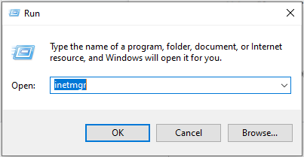

Step -6

----------

Create the Website “Payment API”

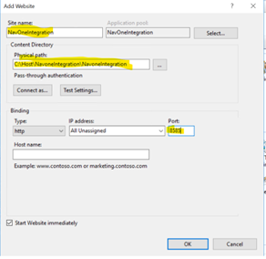

Change the highlighted details based on theEnvironment (Site name , Physical Path & Port)

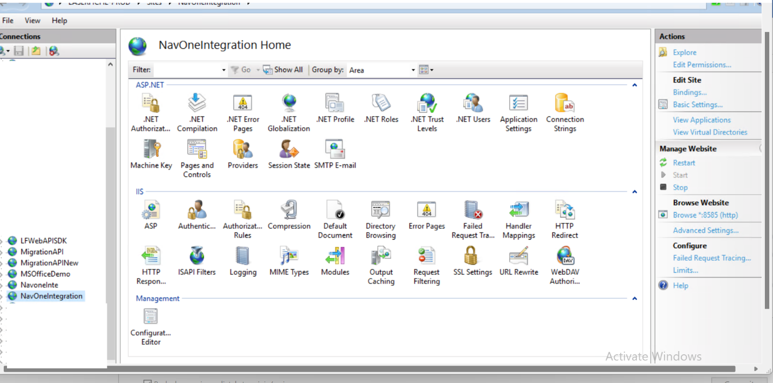

Step -7

----------

Enable the Windows authentication & Set Application Pool Identity Service account.

Step -8

----------

Browse the API URL example <http://192.168.0.12:7171/swagger/index.html>

